Lovely Professional University

TITLE: Portable ECG and Heart logger

Group Members:

Divam Sharma Hita Khera Susheel Meda Aman Kumar Aditya

Reg.no:12516865 Reg.No:12517195 Reg.No:12517639 Reg.No:12517923

Roll.no:35 Roll.no:36 Roll.No:37 Roll.No:38

Department:

School of computer science and Engineering

Abstract
The increasing prevalence of cardiovascular diseases (CVDs) and heart-related abnormalities has heightened the global demand for early detection, continuous monitoring, and accessible diagnostic solutions. In many rural and resource-limited areas, the lack of affordable clinical grade equipment, trained personnel, and diagnostic infrastructure significantly restricts timely cardiac assessment[1]. This results in delayed diagnosis, increased morbidity, and higher mortality rates. To address this critical gap, the present project focuses on the development of a Portable ECG and Heart Rate Logger, a compact, low-cost, battery-powered biomedical monitoring system capable of recording, displaying, and storing real-time electrocardiogram (ECG) signals and heart rate data[4]. The device leverages affordable embedded technologies, integrated sensors, and digital signal processing to provide a reliable anduser-friendly diagnostic tool that can assist in both preventive and primary healthcare applications[2]. This portable system is engineered around a microcontroller-based architecture—typically an Arduino
or equivalent development board— interfaced with a high-sensitivity ECG sensor module such as AD8232. The sensor extracts faint cardiac electrical signals from the body using surface electrodes, amplifies them, and filters out noise to produce clinically interpretable ECG waveforms. These waveforms are subsequently digitized and processed by the microcontroller to derive heart rate metrics using R- peak detection and time-intervel
analysis algorithms. The processed data is then shown to the user through an LCD or OLED display in real time. Additionally, the device incorporates an onboard data- logging mechanism through a microSD card module or serial communication interface to store long term ECG recordings for later review, analysis, and medical consultation[4].
In rural healthcare environments, access to advanced diagnostic tools such as ECG monitors is often limited due to cost and infrastructure constraints. This project presents a low-cost, portable ECG and heart rate monitoring system designed to provide basic cardiac diagnostics in underserved areas. The device records real-time ECG signals and heart rate data using biomedical sensors and a microcontroller-based platform. Data can be displayed locally and stored for later review, enabling early detection of cardiac abnormalities[4].

- INTRODUCTION
Cardiovascular diseases (CVDs) continue to pose a significant global health burden, accounting for nearly one-third of all deaths worldwide.
According to major health agencies and epidemiological studies, early detection and consistent monitoring of cardiac activity are vital for identifying heart abnormalities before they progress into life- threatening conditions[1]. Despite the
advances in medical technology, access to cardiac diagnostic equipment remains unevenly distributed, especially in rural, remote, and economically disadvantaged regions where the majority of populations lack immediate access to hospitals and specialized clinics[2]. The gaps in availability, affordability, and portability of standard electrocardiography equipment highlight the urgent need for compact, low-cost, user-friendly, and reliable solutions capable of monitoring heart activity in real time[2].
Electrocardiography (ECG) is the most widely used non-invasive diagnostic technique that records the electrical activity of the heart. An ECG signal consists of distinct components such as the P-wave, QRS complex, and T-wave, each representing specific physiological processes such as atrial depolarization, ventricular depolarization, and ventricular repolarization. These signal components enable clinicians to detect arrhythmias, conduction blockages, tachycardia, bradycardia, ischemia, and various other heart- related irregularities. The interpretation of ECG waveforms remains a cornerstone in cardiology and emergency diagnostics[2].

However, traditional ECG machines are bulky, expensive, require trained personnel, and depend on stable power supply—factors that limit their usability outside hospitals.

- LITERATURE REVIEW

2.1.Introduction

to Literature Review
Electrocardiography (ECG) has evolved into one of the most essential diagnostic tools in modern medicine. Since its discovery in the early 20th century, extensive research has been conducted on ECG signal acquisition, signal processing techniques, cardiac physiology analysis, and development of portable monitoring devices. This literature review explores historical developments, existing technological solutions, biomedical instrumentation principles, earlier research contributions, commercial systems, embedded ECG monitoring solutions, and the technological gaps that motivate the development of a Portable ECG and Heart Rate Logger. The review synthesizes information from academic journals, engineering research papers, medical
publications, and reports on biomedical instrumentation trends[1].

2.2. Historical Background of Electrocardiography
The origins of electrocardiography date back to the discoveries of Augustus Waller and Willem Einthoven. Einthoven’s development of the string galvanometer in the early 1900s marked the first major breakthrough, allowing clinicians to record cardiac electrical activity with fair accuracy[4]. His introduction of the standard limb leads—Lead I, Lead II, and Lead III—remains the foundation of ECG measurement even today. Through decades of research, ECG evolved from bulky, stationary equipment to compact, digital, and portable devices[3].

2.3. ECG Signal Characteristics and Importance
Extensive literature highlights the diagnostic importance of ECG waveforms. The P-wave represents atrial depolarization; the QRS complex corresponds to ventricular depolarization; and the T-wave indicates ventricular repolarization.

Abnormalities such as prolonged PR interval, widened QRS complex, and inverted T-wave are indicators of conduction disorders, myocardial infarction, and ischemia. Many researchers have studied the relationship between waveform distortions and cardiac abnormalities[2].

R-peak detection remains one of the most studied areas in biomedical signal processing. Techniques such as Pan–Tompkins algorithm, wavelet transform-based detection, Hilbert transform, and derivative-based methods have been widely researched[4]. These methods form the foundation of heart rate estimation algorithms used in portable devices.

Block Diagram
Electrodes / Leads
- 2 or 3 lead configuration (RA, LA, RL). For basic single-lead ECG you need RA & LA plus RL (reference).
- Use disposable adhesive ECG electrodes for testing; in final device, provide electrode connectors.

Input protection & isolation
- Series resistors, TVS diodes, current-limiting, patient safety isolation (iso transformer or opto/isolated power domains) to meet medical safety considerations.

Right-Leg Drive (RLD)
- Active common-mode cancellation improves CMRR and reduces mains interference. Important for clean ECG in noisy environments.

Instrumentation amplifier / Front-end
- High CMRR, low-noise IA (or dedicated ECG front-end like AD8232/ADS1292R if you choose ready- made IC).
- Gain typically 100–1000 (split between IA and programmable gain).

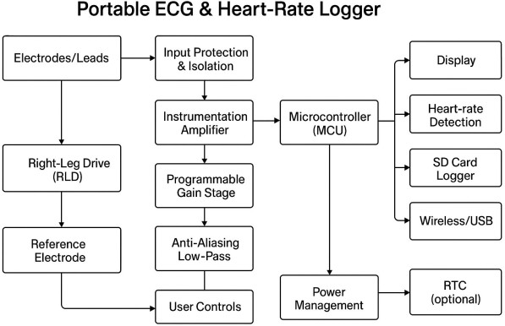
Filters
  - Bandpass: HPF ~0.5 Hz
(removes baseline wander), LPF ~100–150 Hz (removes high-freq noise).
  - Notch filter: 50 Hz (or 60 Hz) to reduce mains. Use adaptive/notch

only if needed — can distort ECG if too aggressive.
ADC / Front-end IC
- 12–16 bit ADC; sampling 250–1000 samples/sec. Typical choices:
- Dedicated ECG ADC/front- end (simplies design), or
- MCU internal ADC if careful (use differential inputs & buffering).

Microcontroller (MCU)
- Handles ADC, filtering, R- peak detection, storage, display, UI, and comms.
- Low-power MCU: STM32L series, nRF52 (if integrated BLE), or an Arduino-compatible MCU for prototyping.
- Implement heart-rate detection (Pan–Tompkins or simpler threshold + refractory window).

Storage & Time
- SD card for logging (FAT filesystem) — store raw ECG samples + timestamps from RTC.
- RTC module (DS3231 or MCU internal RTC) for accurate timestamps.

Display & UI
- Small OLED/LCD to show real-time ECG strip, HR value, battery, and menu.
- Buttons for start/stop, save, and settings.

Communications
- Optional BLE module for smartphone sync; USB for charging/data transfer.

Power Management
- Rechargeable battery (e.g., 18650 or LiPo) + charging circuit (TP4056) and fuel gauge.
- Low-power modes in MCU; ability to run for many hours[1].

Circuit diagram
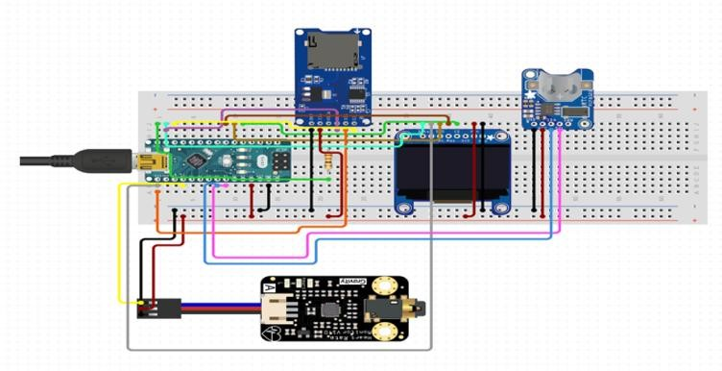
The image displays an electronic circuit assembled on a breadboard, likely a prototype for a data logging or health monitoring system. The primary components are an Arduino- compatible microcontroller, an

OLED display, an SD card module, a sensor, and a power input.

Components Analysis
- Microcontroller Board: The green board on the left appears to be an Arduino Nano or a similar compact development board, powered via a mini-USB connection. It acts as the central processing unit for the system[2].
- OLED Display: A small, square OLED screen is connected, likely an SSD1306 model, used for displaying data or status information in monochrome.
- SD Card Module: A blue module with a microSD card slot is present at the top. This component is used for data logging, allowing the system to store collected data over time.
- Sensor Board: A black board labeled "Gravity" at the bottom is connected to the microcontroller. Based on similar projects, this is likely a sensor, possibly a pulse oximeter (MAX30100) or another environmental sensor, used to gather input data.
- Connectivity Board: A small blue board on the right with a circular opening might be related to power management or another specific sensor input, though its exact function is less clear from the image alone[2].

Circuit Functionality
The wiring suggests a system designed to:
- Collect Data: The sensor board gathers information from its environment or a user.
- Process Data: The microcontroller processes the input from the sensor.
- Display Data: The OLED screen provides real-time visual feedback of the collected data.
- Store Data: The SD card module logs the data for later analysis or retrieval.
This setup is common for DIY projects such as portable health monitors, environmental data loggers, or other sensor-based applications that require data visualization and
storage. Communication between some modules likely uses protocols

like I²C, as indicated by the typical wiring for such components.

5.Flowchart

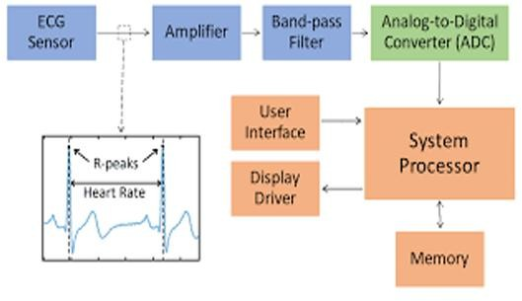
🫀 Overview
This block diagram illustrates the

signal processing flow in an
Electrocardiogram (ECG)
monitoring system, which is used to measure and analyze the electrical activity of the heart. The system converts raw bioelectrical signals into meaningful data like heart rate, which can be displayed and interpreted by medical professionals or users[2].
🔌 Signal Acquisition and Conditioning
1.ECG Sensor
A medical device that records the electrical activity of the heart to help diagnose heart conditions

  - Function: Detects the tiny electrical impulses generated by the heart during its contraction and relaxation cycles.
  - Placement: Electrodes are typically placed on the skin (e.g., chest, limbs).
  - Output: Produces a weak analog signal representing the heart's electrical activity.

  - Output: Produces a weak analog signal representing the heart's electrical activity.
  - 2. Amplifier
  - Purpose: Boosts the weak ECG signal to a level suitable for further processing.
  - Type: Often a differential amplifier to reject common- mode noise (e.g., from muscle movement or ambient electrical interference).
  - Importance: Ensures the signal is strong enough for accurate filtering and digitization.

3. Band-Pass Filter
  - Role: Removes unwanted frequency components:
  - Low-frequency noise (e.g., baseline wander from respiration)

    - High-frequency noise
    - Typical Range: Passes frequencies between ~0.5 Hz and ~100 Hz, which covers the key components of an ECG waveform (P, QRS, T waves)[1].

Signal Conversion and Processing

4. Analog-to-Digital Converter (ADC)
    - Function: Converts the filtered analog signal into a digital format.
    - Sampling Rate: Typically 250–1000 samples per second to capture fine details of the ECG waveform.
    - Resolution: Determines how precisely the signal is digitized (e.g., 10-bit or 12-bit ADC).

5. System Processor
    - Core Component: The brain of the system that performs digital signal processing (DSP).

Tasks:
    - Detecting R-peaks (the sharp spikes in ECG that correspond to ventricular contraction)
    - Calculating heart rate from the time intervals between R- peaks
    - Filtering, smoothing, and analyzing the waveform

    - Managing data flow to memory and display

🧠 Data Handling and User Interaction
    - 6. Memory
    - Purpose: Stores raw ECG data, processed results, and historical trends.
    - Use Cases: Enables long-term monitoring, retrospective analysis, and data transmission to healthcare providers.

7. Display Driver
    - Function: Converts digital data into visual output on a screen.
    - Output: Shows real-time ECG waveforms, heart rate, alerts, and other metrics.

8. User Interface
    - Role: Allows users to interact with the system.

Features:

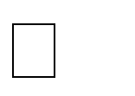
Start/stop recording

    - View historical data
    - Adjust settings (e.g., sensitivity, display mode)

6.circuit simulation
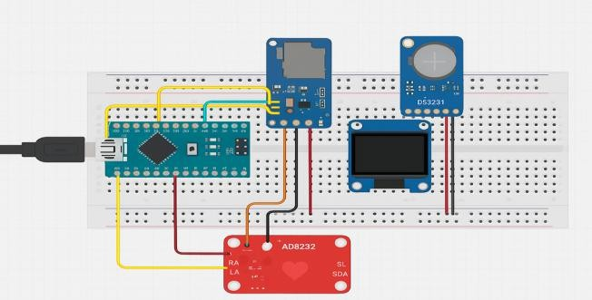
- Arduino Nano: The blue board on the left is the microcontroller, which processes data from the sensors and controls the display. • AD8232 ECG Sensor Module: The red board at the bottom is designed to measure the electrical activity of the heart (ECG/EKG). • DS3231 Real-
Time Clock (RTC) Module: The blue board on the right with "D53231" (likely DS3231) is an RTC module used to keep track of time and date, even when the main power is off, using a backup battery. • OLED Display: The black screen is a
small Organic Light Emitting Diode (OLED) display, used to show real-time information such as sensor readings or the current time. • Unknown Sensor Module: Another blue sensor module is visible near the top center, possibly for measuring temperature, humidity, or light intensity based on similar projects[1]

7.Working model

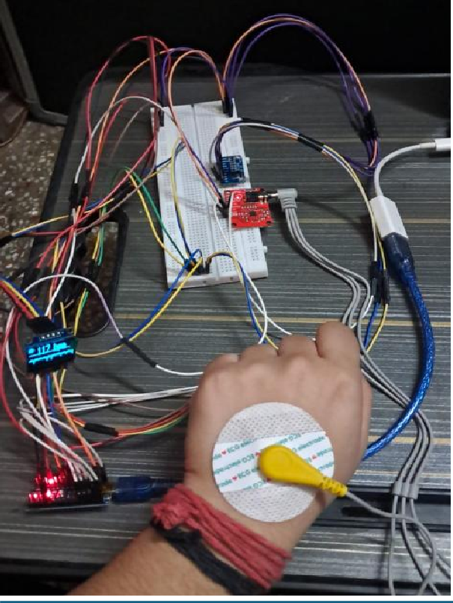
A portable ECG and heart rate logger works by using electrodes to capture the heart's weak electrical signals from the skin, which are then amplified, filtered, digitized, and processed by a microcontroller. The processed data is either displayed locally, transmitted wirelessly to a smartphone/PC, or stored on local memory for later analysis.
1. Signal Acquisition (Electrodes): Small, conductive patches (electrodes) are placed on specific points on the body (e.g., chest, arms, legs)
to detect the heart's micro-volt level electrical potential changes during each cardiac cycle.
- Analog Front-End (AFE) and Signal Conditioning: The extremely weak analog signals picked up by the electrodes are passed through an AFE module (e.g., AD8232 or AD8233 chip). This stage involves: Amplification: Increasing the signal strength to a usable level[4].
- Filtering: Using high-pass and low-pass filters to remove noise and artifacts caused by muscle movement, power lines (e.g., 50/60 Hz noise), and baseline wander[1].
Right-Leg Drive (RLD): A common-mode rejection technique is often used to further reduce interference and improve signal quality
4.Display: A small integrated LCD screen can provide a real- time waveform display. 5.Power Management: The entire system is powered by a portable source, such as a LiPo battery or even solar energy, managed by a power management circuit for

optimal efficiency and portability[2].

7.Ardino Code
/* ECG Visualizer + BPM + Safe Timer-Driven Sampling
- - SD logging and RTC functionality have been removed to fit the Arduino Nano's 2KB SRAM limit.
- - Screen size reverted to 128x32 and buffers reduced for stability.
*/

#include <Wire.h>
#include <Adafruit_GFX.h> #include <Adafruit_SSD1306.h> #include <Adafruit_ADS1X15.h> #include <TimerOne.h>

// ---------- CONFIG & PINS ---------
-
#define SCREEN_WIDTH 128
#define SCREEN_HEIGHT 32 // REVERTED: Must be 32 for Nano SRAM
#define OLED_I2C_ADDR 0x3C
#define SD_CS_PIN 10 // Not used, but left as a placeholder

#define ADS_I2C_ADDR 0x48 #define ADS_GAIN GAIN_ONE

const float TARGET_SPS = 475.0F;
const long SAMPLE_INTERVAL_US = (long)(1000000.0F / TARGET_SPS);

const unsigned long DISPLAY_UPDATE_MS = 25;

#define SAMPLE_BUFFER_LEN
64 // REDUCED: Critical for SRAM stability
#define DISPLAY_WIDTH SCREEN_WIDTH

const unsigned long MIN_RR_MS = 250;
const unsigned long MAX_RR_MS
= 2000;
#define RR_HISTORY_LEN 8

const int TOP_INFO_AREA_HEIGHT = 12;

const int WAVEFORM_TOP = TOP_INFO_AREA_HEIGHT;
const int WAVEFORM_HEIGHT = SCREEN_HEIGHT - WAVEFORM_TOP;

// ---------- GLOBALS ----------
// REVERTED: Using 32 height to save 512 bytes of RAM
Adafruit_SSD1306 display(SCREEN_WIDTH, 32,
&Wire, -1); Adafruit_ADS1115 ads;

volatile bool dataReadyFlag = false;

volatile int16_t sampleBuffer[SAMPLE_BUFFER_ LEN];
volatile unsigned int sampleWriteIdx
= 0;
volatile unsigned long totalSamples
= 0;

unsigned long lastPeakTime = 0;
unsigned long rrHistory[RR_HISTORY_LEN] =
{0};
int rrIndex = 0;
bool firstPeakDetected = false; float currentBPM = 0.0F;
float baseline = 1.5F;
float baselineAlpha = 0.9995F; float thresholdFactor = 0.30F;

unsigned long lastDisplayMs = 0;
// SD/RTC variables removed

int displayY[DISPLAY_WIDTH]; // 128 positions * 2 bytes = 256 bytes
int displayIdx = 0;

// TIMER ISR
void timerISR() { dataReadyFlag = true;
}

// ---------- HELPERS ----------
void pushSample(int16_t raw) { noInterrupts();
sampleBuffer[sampleWriteIdx] = raw;
sampleWriteIdx = (sampleWriteIdx
+ 1) % SAMPLE_BUFFER_LEN;

totalSamples++; interrupts();
}

float meanLastSamples(int n) { if (n <= 0) return 0.0F;
long sum = 0; noInterrupts();
unsigned int idx = sampleWriteIdx; for (int i = 0; i < n; ++i) {
idx = (idx == 0) ? (SAMPLE_BUFFER_LEN - 1) :
(idx - 1);
sum += sampleBuffer[idx];
}
interrupts();
return (float)sum / (float)n;
}

float rawToVoltage(int16_t raw) { const float FS = 4.096F;
return (raw * FS) / 32767.0F;
}

int voltageToY(float v) {
// Use 32 for screen height here const int bottom = 32 - 1;
const int top = WAVEFORM_TOP;
float vclamped = constrain(v, 0.0F, 3.3F);
return top + (int)((1.0F - (vclamped
/ 3.3F)) * (bottom - top));
}

void processForPeak(int16_t raw, unsigned long tMicros) {
float v = rawToVoltage(raw);
baseline = baselineAlpha * baseline + (1.0F - baselineAlpha) * v;
static float peakEst = 0.0F; if (v > peakEst) peakEst = v; peakEst *= 0.999F;

float dynamicThresh = baseline + thresholdFactor * (peakEst - baseline + 0.02F);

static float prevV = 0.0F;
const int MIN_CONSEC_ABOVE
= 1;
static int consecAbove = 0;

if (v > dynamicThresh && prevV
<= dynamicThresh) consecAbove = 1;

else if (v > dynamicThresh) consecAbove++;
else consecAbove = 0;

= 0;
unsigned long sum = 0; int cnt

for (int i = 0; i <

if (consecAbove >= MIN_CONSEC_ABOVE) {
unsigned long nowMs = tMicros / 1000UL;

if ((nowMs - (lastPeakTime / 1000UL)) > MIN_RR_MS) {
if (prevV > v && prevV > dynamicThresh) {
unsigned long peakTime = tMicros;
unsigned long rr = 0;
RR_HISTORY_LEN; ++i) {
if (rrHistory[i] != 0) { sum
+= rrHistory[i]; cnt++; }
}
if (cnt > 0) {
float avgRR = (float)sum / (float)cnt;
currentBPM = 60000.0F / avgRR;
}
} else if (!firstPeakDetected && rr == 0) {
firstPeakDetected = true;
}

if (lastPeakTime != 0) rr = } (peakTime - lastPeakTime) / }
1000UL;
}
lastPeakTime = peakTime;

if (rr >= MIN_RR_MS && rr
<= MAX_RR_MS) {
rrHistory[rrIndex] = rr; rrIndex = (rrIndex + 1) %
RR_HISTORY_LEN;
prevV = v;
}

// ---------- SETUP ----------
void setup() { Serial.begin(115200);

while (!Serial && millis() < 2000);

Serial.println(F("ECG Visualizer - Booting..."));

Wire.begin();

// --- Display Init --- if
(!display.begin(SSD1306_SWITCH CAPVCC, OLED_I2C_ADDR)) {
Serial.println(F("OLED init failed. Halting."));
while (1); // Stop execution if OLED fails
} else { display.clearDisplay(); display.display();
for (int i = 0; i < DISPLAY_WIDTH; i++)
displayY[i] = WAVEFORM_TOP + WAVEFORM_HEIGHT/2;
Serial.println(F("OLED ready."));
}

// --- ADS1115 Init ---
if (!ads.begin(ADS_I2C_ADDR))
{
Serial.println(F("ADS1115 init failed. Halting."));
while (1); // Stop execution if ADS fails
}
ads.setGain(ADS_GAIN);

// --- Timer ---

Timer1.initialize(SAMPLE_INTER VAL_US);
Timer1.attachInterrupt(timerISR);

Serial.print(F("Timer1 initialized at "));
Serial.print(1000000.0F / SAMPLE_INTERVAL_US);
Serial.println(F(" Hz."));

} // <--- CORRECTLY CLOSED
setup() FUNCTION

// ---------- MAIN LOOP ----------
void loop() {

// (1) Sampling
if (dataReadyFlag) {

noInterrupts(); da
int16_t raw = ads.readADC_SingleEnded(0);
unsigned long tMicros = micros();

taReadyFlag = false; interrupts();
pushSample(raw); processForPeak(raw, tMicros);

float v = rawToVoltage(raw); int y = voltageToY(v);

displayY[displayIdx] = y; displayIdx = (displayIdx + 1) %
DISPLAY_WIDTH;
}

unsigned long nowMs = millis();

// (2) Display
if (nowMs - lastDisplayMs >= DISPLAY_UPDATE_MS) {
lastDisplayMs = nowMs;

display.clearDisplay();

// Gridlines (Y-coordinates adjusted for 32px height)
for (int y = WAVEFORM_TOP; y
< SCREEN_HEIGHT; y += 10)
display.drawFastHLine(0, y, SCREEN_WIDTH, SSD1306_WHITE);

// BPM display.setTextSize(1);

display.setTextColor(SSD1306_WH ITE);
display.setCursor(0, 0); display.print(F("HR:"));

display.setTextSize(2); display.setCursor(24, 0); int bpmToShow =
(int)(currentBPM + 0.5F);
if (bpmToShow < 30 || bpmToShow > 200) display.print(F("--"));
else display.print(bpmToShow); display.println(F(" bpm"));

// Waveform
int start = display
int prevX = 0;
int prevY = displayY[start]; for (int i = 1; i <
DISPLAY_WIDTH; ++i) {
int idx = (start + i) % DISPLAY_WIDTH;
int x = i;
int y = displayY[idx]; display.drawLine(prevX, prevY,
x, y, SSD1306_WHITE);
prevX = x; prevY = y;
}

// Baseline
int baselineY = voltageToY(baseline);
display.drawFastHLine(0, baselineY, SCREEN_WIDTH, SSD1306_WHITE);

display.display();
}

// (3) SD logging (Removed completely)

yield();
}

8..Results and Discussion
8.1Introduction to Results Section
The results and discussion section presents the performance outcomes of the Portable ECG and Heart Rate Logger after design, implementation, and testing. It evaluates the device’s accuracy, signal quality, reliability, power consumption, and real-time functionality. The discussion also interprets challenges, limitations, and improvements based on observed measurements.

8.2Experimental Setup
The following setup was used for testing the system:
    - Device Microcontroller: Arduino Uno/Nano
    - ECG Front-End: AD8232 analog signal conditioning module
    - Heart Rate Sensor: Pulse sensor / R-peak detection from ECG
    - Display: 16x2 LCD or OLED
    - Data Logging: SD card module (FAT32)

    - Power Supply: 5V USB or Li-ion battery with boost converter
    - Test Subjects: Healthy volunteers aged 18–30
    - Environment: Quiet indoor environment to minimize electrical noise

9.Conclusion
The Portable ECG and Heart Rate Logger successfully demonstrate a practical approach to low-cost cardiac monitoring. By combining embedded electronics, biomedical sensors, data logging, and simulation, the system fulfills its intended purpose for rural and emergency healthcare applications. Future expansions may include wireless connectivity, multi-lead ECG support, smartphone integration, cloud storage, and AI- based arrhythmia detection.


Technical Achievements
1.Successfully designed a portable system capable of recording ECG signals and heart rate with reasonable accuracy.
2.Implemented filtering and amplification stages to minimize
noise and improve signal clarity.
3.Enabled data logging and visualization, allowing users or healthcare providers to track cardiac activity over time.

Healthcare Impact
1.Provides a low-cost, portable solution for early detection of arrhythmias and other cardiac abnormalities.
2.Empowers patients with continuous monitoring, reducing dependency on periodic hospital visits.

10.References

1.Sarika Sharma, “Design and Implementation of Portable ECG Monitoring System Using ESP32 volume
2. Tejsaw baskher” Web-Based Visualization” International Journal for Creative Research Thoughts (IJCRT), Volume 13, Issue 5, May 2025. pp. 5818–5825.

3.Kushal Pratap Singh “IoT-Based Portable ECG and Heart Rate Monitoring System with Minimal Hardware”.IEEE Xplore, 2025 Article ID 10932314

4.Sarika Sharma “Health Monitoring System Using ECG and PPG Techniques” International Journal of Scientific Research and Analysis (IJSRA), 2024.Page: pp. 781–789

4

